**INDIA GENERAL ELECTIONS RESULT ANALYSIS 2024**

**--- PROBLEM STATEMENT :- 01 Total Seats**

**SELECT**

**DISTINCT COUNT(Parliament_Constituency)**

**FROM constituencywise_results;**



**--- PROBLEM STATEMENT :- 02 What is the total number of seats available for elections in each state.**

**SELECT states.State AS StateName, COUNT(Constituency_ID) AS TotalSeatsAvailable**

**FROM states**

**JOIN**

**statewise_results**

**ON states.State_ID = statewise_results.State_ID**

**JOIN**

**constituencywise_results**

**ON constituencywise_results.Parliament_Constituency = statewise_results.Parliament_Constituency**

**GROUP BY**

**states.State**

**ORDER BY**

**states.State;**

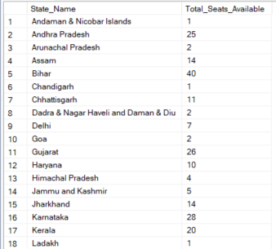 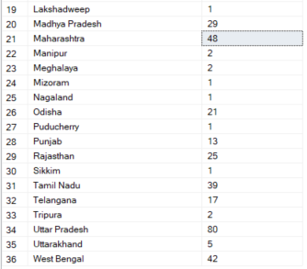

**--- PROBLEM STATEMENT :- 03 Total Seats Won by NDA Alliance**

**SELECT**

**SUM(CASE**

**WHEN Party IN (**

**'Apna Dal (Soneylal) - ADAL',**

**'Asom Gana Parishad - AGP',**

**'Bharatiya Janata Party - BJP',**

**'Hindustani Awam Morcha (Secular) - HAMS',**

**'Janasena Party - JnP',**

**'Janata Dal (Secular) - JD(S)',**

**'Janata Dal (United) - JD(U)',**

**'Lok Janshakti Party(Ram Vilas) - LJPRV',**

**'Nationalist Congress Party - NCP',**

**'Rashtriya Janata Dal - RJD',**

**'Rashtriya Lok Dal - RLD',**

**'Shiv Sena - SHS',**

**'Sikkim Krantikari Morcha - SKM',**

**'Telugu Desam - TDP'**

**) THEN [won]**

**ELSE 0**

**END) AS NDA_Total_Seats_Won**

**FROM partywise_results**

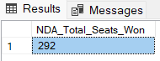

**--- PROBLEM STATEMENT :- 04 Seats Won by NDA Alliance Party**

**SELECT**

**party AS PartyName,**

**won AS SeatsWon**

**FROM**

**partywise_results**

**WHERE**

**party IN (**

**'Apna Dal (Soneylal) - ADAL',**

**'Asom Gana Parishad - AGP',**

**'Bharatiya Janata Party - BJP',**

**'Hindustani Awam Morcha (Secular) - HAMS',**

**'Janasena Party - JnP',**

**'Janata Dal (Secular) - JD(S)',**

**'Janata Dal (United) - JD(U)',**

**'Lok Janshakti Party(Ram Vilas) - LJPRV',**

**'Nationalist Congress Party - NCP',**

**'Rashtriya Janata Dal - RJD',**

**'Rashtriya Lok Dal - RLD',**

**'Shiv Sena - SHS',**

**'Sikkim Krantikari Morcha - SKM',**

**'Telugu Desam - TDP'**

**)**

**ORDER BY SeatsWon DESC;**

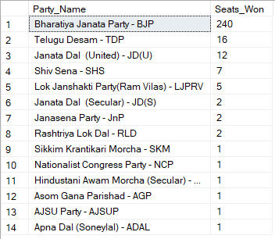

**--- PROBLEM STATEMENT :- 05 Total Seats Won by I.N.D.I.A Alliance Parties**

**SELECT**

**SUM(CASE**

**WHEN Party IN (**

**'Aam Aadmi Party - AAAP',**

**'All India Trinamool Congress - AITC',**

**'Bharat Adivasi Party - BHRTADVSIP',**

**'Communist Party of India (Marxist) - CPI(M)',**

**'Communist Party of India (Marxist-Leninist) (Liberation) - CPI(ML)(L)',**

**'Communist Party of India - CPI',**

**'Dravida Munnetra Kazhagam - DMK',**

**'Indian National Congress - INC',**

**'Indian Union Muslim League - IUML',**

**'Jammu & Kashmir National Conference - JKN',**

**'Jharkhand Mukti Morcha - JMM',**

**'Kerala Congress - KEC',**

**'Marumalarchi Dravida Munnetra Kazhagam - MDMK',**

**'Nationalist Congress Party Sharadchandra Pawar - NCPSP',**

**'Rashtriya Loktantrik Party - RLTP',**

**'Revolutionary Socialist Party - RSP',**

**'Samajwadi Party - SP',**

**'Shiromani Akali Dal - SAD',**

**'Shiv Sena (Uddhav Balasaheb Thackrey) - SHSUBT',**

**'Viduthalai Chiruthaigal Katchi - VCK'**

**)THEN [won]**

**ELSE 0**

**END) AS NDA_Total_Seats_Won**

**FROM partywise_results;**



**--- PROBLEM STATEMENT :- 06 Seats Won by I.N.D.I.A Alliance Parties**

**SELECT**

**party AS PartyName,**

**won AS SeatsWon**

**FROM**

**partywise_results**

**WHERE**

**party IN (**

**'Aam Aadmi Party - AAAP',**

**'All India Trinamool Congress - AITC',**

**'Bharat Adivasi Party - BHRTADVSIP',**

**'Communist Party of India (Marxist) - CPI(M)',**

**'Communist Party of India (Marxist-Leninist) (Liberation) - CPI(ML)(L)',**

**'Communist Party of India - CPI',**

**'Dravida Munnetra Kazhagam - DMK',**

**'Indian National Congress - INC',**

**'Indian Union Muslim League - IUML',**

**'Jammu & Kashmir National Conference - JKN',**

**'Jharkhand Mukti Morcha - JMM',**

**'Kerala Congress - KEC',**

**'Marumalarchi Dravida Munnetra Kazhagam - MDMK',**

**'Nationalist Congress Party Sharadchandra Pawar - NCPSP',**

**'Rashtriya Loktantrik Party - RLTP',**

**'Revolutionary Socialist Party - RSP',**

**'Samajwadi Party - SP',**

**'Shiromani Akali Dal - SAD',**

**'Shiv Sena (Uddhav Balasaheb Thackrey) - SHSUBT',**

**'Viduthalai Chiruthaigal Katchi - VCK'**

**)**

**ORDER BY SeatsWon DESC;**

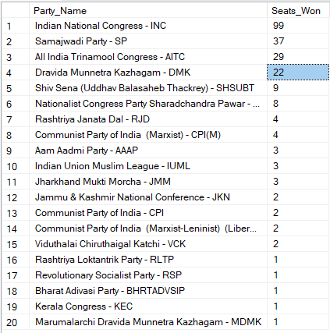

**--- PROBLEM STATEMENT :- 07 Add new column field in table partywise_results to get the Party Alliance as NDA, I.N.D.I.A and OTHER**

**ALTER TABLE partywise_results**

**ADD party_alliance VARCHAR(50)**

**UPDATE partywise_results**

**SET party_alliance = 'I.N.D.I.A'**

**WHERE party IN (**

**'Aam Aadmi Party - AAAP',**

**'All India Trinamool Congress - AITC',**

**'Bharat Adivasi Party - BHRTADVSIP',**

**'Communist Party of India (Marxist) - CPI(M)',**

**'Communist Party of India (Marxist-Leninist) (Liberation) - CPI(ML)(L)',**

**'Communist Party of India - CPI',**

**'Dravida Munnetra Kazhagam - DMK',**

**'Indian National Congress - INC',**

**'Indian Union Muslim League - IUML',**

**'Jammu & Kashmir National Conference - JKN',**

**'Jharkhand Mukti Morcha - JMM',**

**'Kerala Congress - KEC',**

**'Marumalarchi Dravida Munnetra Kazhagam - MDMK',**

**'Nationalist Congress Party Sharadchandra Pawar - NCPSP',**

**'Rashtriya Loktantrik Party - RLTP',**

**'Revolutionary Socialist Party - RSP',**

**'Samajwadi Party - SP',**

**'Shiromani Akali Dal - SAD',**

**'Shiv Sena (Uddhav Balasaheb Thackrey) - SHSUBT',**

**'Viduthalai Chiruthaigal Katchi - VCK'**

**);**

**UPDATE partywise_results**

**SET party_alliance = 'NDA'**

**WHERE party IN (**

**'Apna Dal (Soneylal) - ADAL',**

**'Asom Gana Parishad - AGP',**

**'Bharatiya Janata Party - BJP',**

**'Hindustani Awam Morcha (Secular) - HAMS',**

**'Janasena Party - JnP',**

**'Janata Dal (Secular) - JD(S)',**

**'Janata Dal (United) - JD(U)',**

**'Lok Janshakti Party(Ram Vilas) - LJPRV',**

**'Nationalist Congress Party - NCP',**

**'Rashtriya Janata Dal - RJD',**

**'Rashtriya Lok Dal - RLD',**

**'Shiv Sena - SHS',**

**'Sikkim Krantikari Morcha - SKM',**

**'Telugu Desam - TDP'**

**);**

**UPDATE partywise_results**

**SET party_alliance = 'OTHER'**

**WHERE party_alliance IS NULL;**

**---PROBLEM STATEMENT :- 08 Which party alliance (NDA, I.N.D.I.A, or OTHER) won the most seats across all states?**

**SELECT**

**party_alliance,**

**SUM(won) AS Total**

**FROM partywise_results**

**GROUP BY party_alliance;**

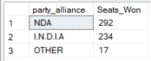

**---PROBLEM STATEMENT :- 09 Winning candidate's name, their party name, total votes, and the margin of victory for a specific state and constituency?**

**SELECT constituencywise_results.Winning_Candidate,**

**partywise_results.Party,**

**constituencywise_results.Total_Votes,**

**constituencywise_results.Margin,**

**constituencywise_results.Constituency_Name,**

**partywise_results.party_alliance,**

**States.State**

**FROM constituencywise_results**

**JOIN partywise_results**

**ON constituencywise_results.Party_ID = partywise_results.Party_ID**

**JOIN statewise_results**

**ON constituencywise_results.Parliament_Constituency = statewise_results.Parliament_Constituency**

**JOIN States**

**ON statewise_results.State_ID = States.State_ID**



**---PROBLEM STATEMENT :- 10 What is the distribution of EVM votes for candidates in a specific constituency ?**

**SELECT constituencywise_details.Candidate,**

**constituencywise_details.Party,**

**constituencywise_details.EVM_Votes,**

**constituencywise_details.Postal_Votes,**

**constituencywise_details.Total_Votes,**

**constituencywise_results.Constituency_Name**

**FROM constituencywise_details**

**JOIN constituencywise_results**

**ON constituencywise_details.Constituency_ID = constituencywise_results.Constituency_ID**

**ORDER BY constituencywise_details.Total_Votes DESC;**

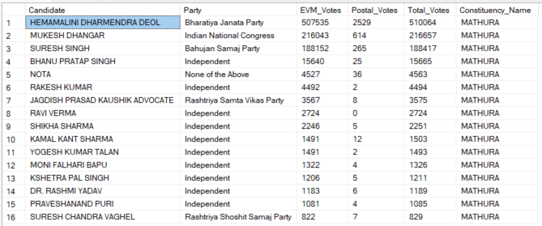

**---PROBLEM STATEMENT :- 11 Which parties won the most seats in states.State, and how many seats did each party win?**

**SELECT partywise_results.Party,**

**COUNT(Constituency_ID) AS Seats_won**

**FROM partywise_results**

**JOIN constituencywise_results**

**ON constituencywise_results.Party_ID = partywise_results.Party_ID**

**JOIN statewise_results**

**ON statewise_results.Parliament_Constituency = constituencywise_results.Parliament_Constituency**

**JOIN states**

**ON states.State_ID = statewise_results.State_ID**

**WHERE states.State = 'Andhra Pradesh'**

**GROUP BY partywise_results.Party**

**ORDER BY Seats_Won DESC;**

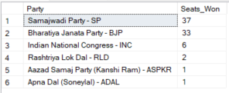

**---PROBLEM STATEMENT :- 12 What is the total number of seats won by each party alliance (NDA, I.N.D.I.A, and OTHER) in each state for the India Elections 2024**

**SELECT**

**states.State AS State_Name,**

**SUM(CASE WHEN partywise_results.party_alliance = 'NDA' THEN 1 ELSE 0 END) AS NDA_Seats_Won,**

**SUM(CASE WHEN partywise_results.party_alliance = 'I.N.D.I.A' THEN 1 ELSE 0 END) AS INDIA_Seats_Won,**

**SUM(CASE WHEN partywise_results.party_alliance = 'OTHER' THEN 1 ELSE 0 END) AS OTHER_Seats_Won**

**FROM constituencywise_results**

**JOIN partywise_results**

**ON constituencywise_results.Party_ID = partywise_results.Party_ID**

**JOIN statewise_results**

**ON constituencywise_results.Parliament_Constituency = statewise_results.Parliament_Constituency**

**JOIN states**

**ON statewise_results.State_ID = states.State_ID**

**WHERE partywise_results.party_alliance IN ('NDA', 'I.N.D.I.A', 'OTHER') -- Filter for NDA and INDIA alliances**

**GROUP BY states.State**

**ORDER BY states.State;**

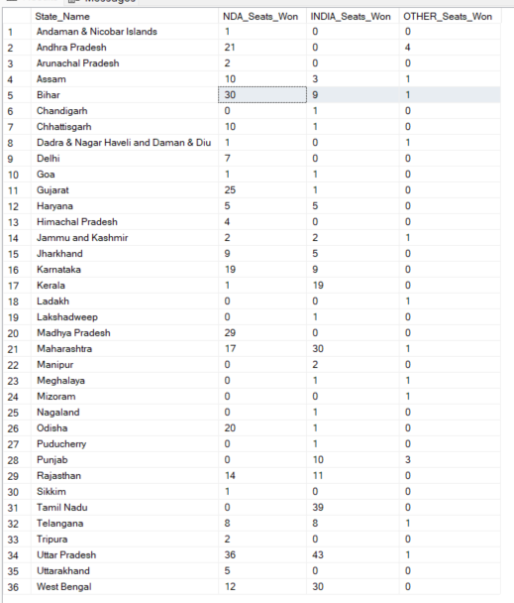

**---PROBLEM STATEMENT :- 13 Which candidate received the highest number of EVM votes in each constituency (Top 10)?**

**SELECT TOP 10**

**constituencywise_results.Constituency_ID,**

**constituencywise_results.Constituency_Name,**

**constituencywise_details.Candidate,**

**constituencywise_details.EVM_Votes**

**FROM constituencywise_details**

**JOIN constituencywise_results**

**ON constituencywise_details.Constituency_ID = constituencywise_results.Constituency_ID**

**ORDER BY constituencywise_details.EVM_Votes DESC;**

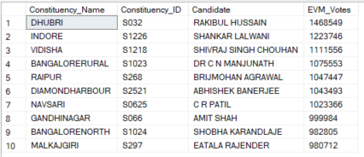

**---PROBLEM STATEMENT :- 14 Which candidate won and which candidate was the runner-up in each constituency of State for the 2024 elections?**

**WITH RankedCandidates AS (**

**SELECT**

**constituencywise_details.Constituency_ID,**

**constituencywise_details.Candidate,**

**constituencywise_details.Party,**

**constituencywise_details.EVM_Votes,**

**constituencywise_details.Postal_Votes,**

**constituencywise_details.EVM_Votes + constituencywise_details.Postal_Votes AS Total_Votes,**

**ROW_NUMBER() OVER (PARTITION BY constituencywise_details.Constituency_ID ORDER BY constituencywise_details.EVM_Votes + constituencywise_details.Postal_Votes DESC) AS VoteRank**

**FROM constituencywise_details**

**JOIN constituencywise_results**

**ON constituencywise_details.Constituency_ID = constituencywise_results.Constituency_ID**

**JOIN statewise_results**

**ON constituencywise_results.Parliament_Constituency = statewise_results.Parliament_Constituency**

**JOIN states**

**ON statewise_results.State_ID = states.State_ID**

**WHERE states.State = 'Maharashtra'**

**)**

**SELECT**

**constituencywise_results.Constituency_Name,**

**MAX(CASE WHEN RankedCandidates.VoteRank = 1 THEN RankedCandidates.Candidate END) AS Winning_Candidate,**

**MAX(CASE WHEN RankedCandidates.VoteRank = 2 THEN RankedCandidates.Candidate END) AS Runnerup_Candidate**

**FROM RankedCandidates**

**JOIN constituencywise_results**

**ON RankedCandidates.Constituency_ID = constituencywise_results.Constituency_ID**

**GROUP BY constituencywise_results.Constituency_Name**

**ORDER BY constituencywise_results.Constituency_Name;**

***Query Explaination:***

**1. Common Table Expression (CTE) RankedCandidates**

* **WITH RankedCandidates AS**: This section creates a Common Table Expression (CTE) named RankedCandidates, which is used to rank candidates based on their total votes within each constituency.
* **SELECT ... FROM constituencywise_details cd**: This part of the CTE retrieves data from the constituencywise_details table, including:
  + cd.Constituency_ID: The ID of the constituency.
  + cd.Candidate: The name of the candidate.
  + cd.Party: The party of the candidate.
  + cd.EVM_Votes: The number of EVM votes received by the candidate.
  + cd.Postal_Votes: The number of postal votes received by the candidate.
  + cd.EVM_Votes + cd.Postal_Votes AS Total_Votes: The total votes received by the candidate (sum of EVM and postal votes).
* **ROW_NUMBER() OVER (PARTITION BY cd.Constituency_ID ORDER BY cd.EVM_Votes + cd.Postal_Votes DESC) AS VoteRank**:
  + ROW_NUMBER() is a window function that assigns a unique rank to each candidate within their respective constituency.
  + PARTITION BY cd.Constituency_ID ensures that the ranking is done separately for each constituency.
  + ORDER BY cd.EVM_Votes + cd.Postal_Votes DESC orders candidates by their total votes in descending order, so the candidate with the most votes gets rank 1.
* **JOIN ... ON ...**: Joins are performed to combine information from related tables:
  + constituencywise_results cr ON cd.Constituency_ID = cr.Constituency_ID
  + statewise_results sr ON cr.Parliament_Constituency = sr.Parliament_Constituency
  + states s ON sr.State_ID = s.State_ID
* **WHERE s.State = 'Maharashtra'**: Filters the results to include only data related to the state of Maharashtra.

**2. Main Query**

* **SELECT ... FROM RankedCandidates rc**: The main query retrieves data from the RankedCandidates CTE to find the winning and runner-up candidates for each constituency.
* **MAX(CASE WHEN rc.VoteRank = 1 THEN rc.Candidate END) AS Winning_Candidate**:
  + CASE WHEN rc.VoteRank = 1 THEN rc.Candidate END selects the candidate with the highest vote rank (rank 1) for each constituency.
  + MAX(...) ensures that only one candidate is selected for each constituency.
* **MAX(CASE WHEN rc.VoteRank = 2 THEN rc.Candidate END) AS Runnerup_Candidate**:
  + CASE WHEN rc.VoteRank = 2 THEN rc.Candidate END selects the candidate with the second highest vote rank (rank 2) for each constituency.
  + MAX(...) ensures that only one candidate is selected for each constituency.
* **JOIN ... ON ...**: Joins the RankedCandidates CTE with the constituencywise_results table to get the constituency names.
* **GROUP BY cr.Constituency_Name**: Groups the results by constituency name to ensure that the winning and runner-up candidates are determined for each constituency.
* **ORDER BY cr.Constituency_Name**: Orders the results alphabetically by constituency name for easier readability.

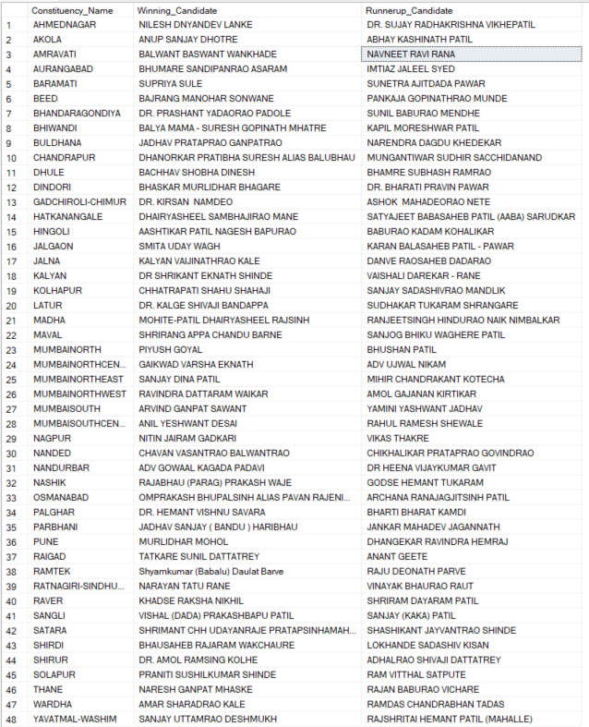

**---PROBLEM STATEMENT :- 15 For the state of Maharashtra, what are the total number of seats, total number of candidates, total number of parties, total votes (including EVM and postal), and the breakdown of EVM and postal votes?**

**SELECT**

**COUNT(DISTINCT constituencywise_results.Constituency_ID) AS Total_Seats,**

**COUNT(DISTINCT constituencywise_details.Candidate) AS Total_Candidates,**

**COUNT(DISTINCT partywise_results.Party) AS Total_Parties,**

**SUM(constituencywise_details.EVM_Votes + constituencywise_details.Postal_Votes) AS Total_Votes,**

**SUM(constituencywise_details.EVM_Votes) AS Total_EVM_Votes,**

**SUM(constituencywise_details.Postal_Votes) AS Total_Postal_Votes**

**FROM constituencywise_results**

**JOIN constituencywise_details**

**ON constituencywise_results.Constituency_ID = constituencywise_details.Constituency_ID**

**JOIN statewise_results**

**ON constituencywise_results.Parliament_Constituency = statewise_results.Parliament_Constituency**

**JOIN states**

**ON statewise_results.State_ID = states.State_ID**

**JOIN partywise_results**

**ON constituencywise_results.Party_ID = partywise_results.Party_ID**

**WHERE states.State = 'Maharashtra';**

